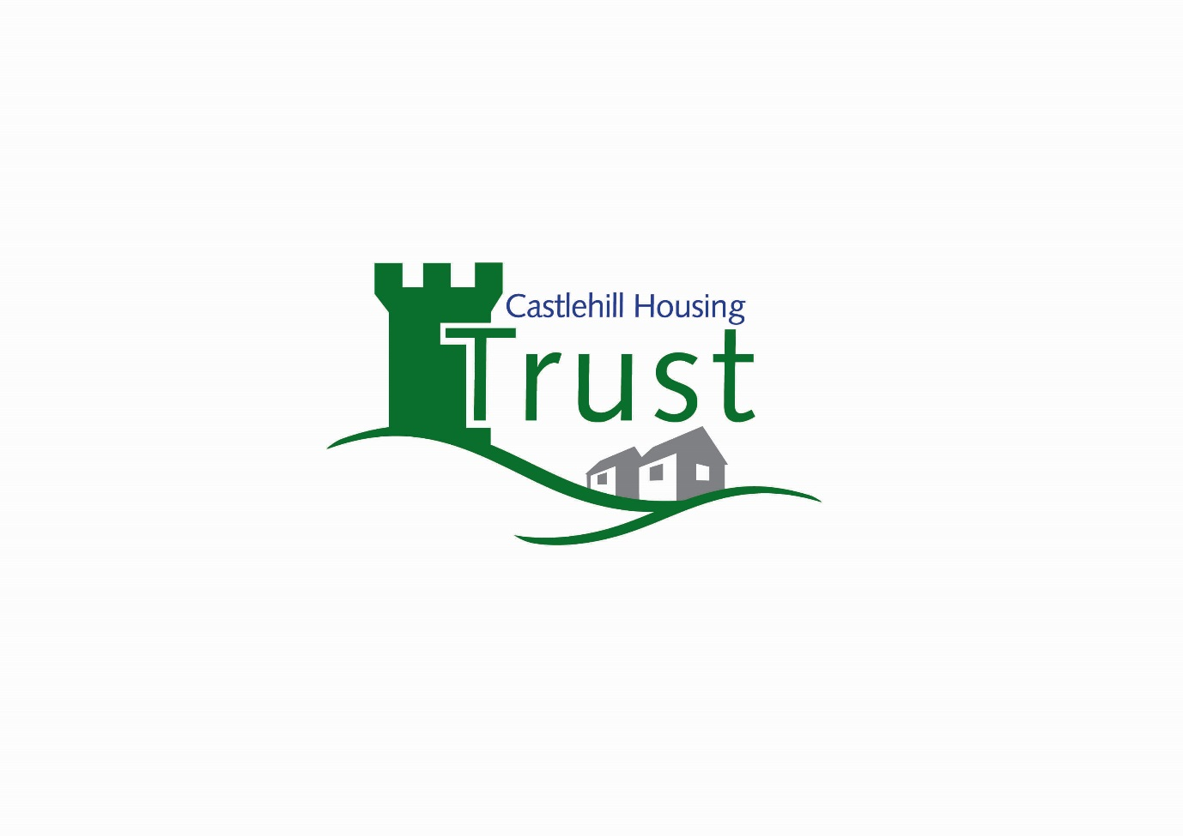

Business Plan 2020– 2022

CHT is a subsidiary of Castlehill Housing Association Limited 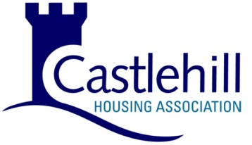

Castlehill Housing Trust

Business Plan 2010-2022

Contents

 | Page
Introduction | 2
About CHT | 2
Strategic objectives 2020-22 | 4
Structure | 7
Housing stock maintenance | 7
Rent & service charges | 8
New housing opportunities | 8
Staffing & service | 9
Policy & procedures development | 9
Risks & Controls | 10
Appendix 1 – Property details

Introduction

This document sets out the intended business activities of Castlehill Housing Trust (hereafter referred to as CHT) for the period 2020 to 2022. CHT is a subsidiary of the Registered Social Landlord, Castlehill Housing Association Ltd. CHT is a company limited by guarantee (company number SC168624) and recognised as a charity by the Office of the Scottish Charity Regulator (OSCR) (charity number SC025334).
CHT helps Castlehill Housing Association to deliver on its Aims and Objectives as a charitable organisation, but retains its distinct identity and specialism in the housing options it delivers. CHT is managed in a way that is “self-sufficient” ensuring that CHT has its own income stream that can cover all their outlays and obligations, and will have no negative impact on the financial position of Castlehill Housing Association.
This document should be read in the context of CHT’s financial projections that are designed to underpin the delivery of its Business Plan.

About CHT

From its formation in 1996, CHT’s remit was to develop supported housing in response to the increasing demand for adapted accommodation for people with particular needs. This has included people with physical disabilities, sensory disabilities, autistic spectrum disorder and challenging behaviour.
To develop this type of housing CHT has worked in partnership with Local Authorities, Grampian NHS, banks and building societies, and secured government grants including special needs capital grant (SNCG), private sector housing grants, local authority grant funding and section 75 grants, as well as private loans.
This has resulted in CHT housing over 150 people in properties that range from group homes (including Houses in Multiple Occupation), homes for families and homes for individuals.
CHT rents properties to individual tenants through Private Residential Tenancies (prior to December 2017 Assured tenancies) and leases directly to service providers (who hold occupancy agreements with their service users).
The care service provided in the properties depends on the needs of the individual. In some cases, for example, in homes provided for families, the family members provide the primary care for a relative, while in other cases a service provider commissioned by the local authority will be the primary carer and will be registered with the Care Inspectorate. The Trust is not registered with the Care Inspectorate as it does not provide any care services.
Appendix 1 summarises the types of Trust properties, their locations and, where relevant, which service provider is responsible for the care of the tenants or occupants and how the care is defined by the Care Inspectorate.

Strategic Objectives 2020 - 2022

Objective | Action | Delivery
CHT remains a financially viable organisation in order to meet its other strategic objectives as set out below. | New rent points policy in place since April 2019 delivers income that is at a level that maintains financial viability whilst remaining affordable for residents. | Appropriate rent and service charge setting with clear rent pointing process. To ensure the rents clearly define the components of the individual properties, and within this the legal requirements that we have to meet.  Priced and budgeted programmes for property maintenance.  Annual Budget Approved by the Board  External audit of CHT annual accounts.  Compliance with the Office of the Scottish Charity Regulator’s accounting regulations.
Work in partnership with local authorities and other organisations that share the same aims as CHT to contribute to the housing of people with particular needs. | CHT enhances its profile as an organisation that ‘champions’ the provision of housing for people with particular needs. | Attend strategic meetings that will allow CHT to contribute to strategies such as local housing and community care strategies, and identify client groups that would benefit from housing that meets their specific needs.
Raise the profile of CHT in the wider community which commenced in May 2019 with a rebrand event promoting our new name and ethos and aims. | CHT enhances its distinct identity and its link to Castlehill HA. | Publicity around CHT events and increased contact with residents and their guardians.

Objective | Target | Delivery
Identify funding to provide a development programme to house people with particular needs. | CHT will lease 5 properties from Castlehill Housing Association in Aberdeenshire in May 2020 to meet the increasing demand in Aberdeenshire to house adults with learning disabilities in individual tenancies. | Access funding through working in partnership with organisations with a similar vision to CHT.
CHT plays an active role in supporting the Health and Social Care (Scotland) Agenda and its partnership organisations. | CHT will be seen as an important contributor of housing solutions for people with specific needs | Input to Health and Social Care Strategic Plan. Close working with local authority and health staff.
Ensure that the Trust’s properties comply with Health and Safety legislation. | All properties have fire safety measures that comply with all current relevant legislation.  All Houses in Multiple Occupation maintain their licenses.  Each year 20% of the Trust’s properties, on a rolling programme, pass the Electrical Installation Condition inspections.  Ensure that all Trust properties remain compliant with legislative requirements regarding legionella | Continue to carry out fire risk assessments and review on an annual basis or when required.  Liaise with the local authorities to ensure the Trust is up to date with the latest Houses in Multiple Occupation legislation. Annual PAT testing and boiler servicing and regular PEI’s and legionella testing (where applicable) are carried out regularly to ensure compliance.  There is an annual programme of property and void inspections.  Programmed testing, inspection and reporting.  The Energy Efficiency (Private Rented Property) (Scotland) Regulations 2019 will start to be phased in from 1st April 2020. By April 2025 all CHT properties will meet standard D or above unless this is not feasible or costs are over £5000 to enable this to happen.
Objective | Target | Delivery
Ensure that CHT continues to adapt properties to ensure people can live in homes to meet their needs. | CHT will respond positively to requests to adapt property to continue to meet residents needs | Through contact with local authorities, tenants and care providers, CHT considers potential adaptations and discusses potential funding options to meet their requirements.
Ensure a quality management, maintenance and support service. | Targets as set out in the Service Level Agreement with Castlehill Housing Association are met. | Performance is reported to the Trust’s Board on a quarterly basis.
Aspire to complying with the Scottish Housing Quality Standards and EESSH in line with the parent RSL, Castlehill HA. | Life cycle costing of the stock was updated in 2019 to inform a planned maintenance programme and ensure our properties remain fit for purpose. | Stock information surveys and all EPC’s completed in 2019.  Input data into QL with which to produce annual planned maintenance budgets.

The table above outlines CHT’s Strategic Objectives and further commentary on issues to be considered by the Board during the period of this Plan is given below.

Structure

The Trust is governed by a Board of up to 11 members, who meet at least 4 times a year. A maximum of 6 Board members may be representatives of Castlehill Housing Association, CHT’s parent Company. CHT aims to ensure that the structure and make up of its Board delivers a balanced approach with a range of experience and knowledge. The Board recognises that overall strategic control sits with Castlehill, but that CHT must operate and deliver its services in its own distinctive way meeting the particular needs of its clients. Given the close alignment of the aims and objectives of Castlehill and CHT as charitable organisations, it is not envisaged that any conflict of approach should arise.
During the period of this Plan, CHT will keep Board membership under review to ensure it is fit for purpose and that we have the balance of skills and knowledge required to oversee operations and ensure the interests of CHT tenants are protected. All CHT Board members have signed up to a Code of Conduct ensuring that compliance and accountability are adhered to at all times. In addition to Castlehill representation, we will aim to maintain input from local authority representatives and client support providers.

Housing Stock Maintenance

Surveys of all CHT Stock was undertaken during 2018-2019 and this has enabled accurate Life Cycle Costing data to be maintained on the Association’s QL computer system.
The life cycle costing has enabled a planned maintenance programme to be devised in conjunction with the CHT Manager and Finance, to ensure there is a rolling programme of improvements across the stock. The close working between departments also allows provision for factors where planned maintenance may have to move to reactive, where there has been a quick deterioration in items such as windows.
Legislation such as HMO licence conditions ensures that our stock meets a high standard of repair, and continuously evolves to meet the needs of our legislation and the individual needs of our tenants.

Rent and Service Charges

CHT reviews its rent and service charges annually, having implemented a new rents point structure from 1stApril 2019. Rents will continue to be set at levels to ensure CHT has sufficient income to meet all its obligations and maintains sufficient future reserves for planned maintenance. We will endeavour to ensure that our rents represent the components and reflect the provision of equipment in our properties. However, we need to be mindful of our current classification as “Supported Accommodation” and how we ensure that we continue to receive this exemption so we are not affected by local housing allowance.
Service equalisation accounts are now in place for each development and will be closely monitored and reviewed annually to ensure service charges accurately reflect actual and estimated costs, and are tailored to specific services at each scheme. There are now programmes in place for servicing disability equipment on a regular basis to ensure that where the servicing is the responsibility of CHT, that we are meeting our obligations. Provision for replacement of fixtures, fittings and equipment are also now in place and will be kept under review.

New Housing Opportunities

CHT recognises the challenges in funding new housing development through public monies following the withdrawal of SNCG and the difficult public funding climate at present. CHT will continue to maximise opportunities for growth, providing this can be done within available resources and without a negative impact on existing tenants and the maintenance of existing property. In 2020 we funded the reconfiguration of an existing HMO to provide en-suite bathrooms and more usable laundry and accommodation for staff. In 2020 with the approval of the CHT board, we propose to reconfigure and extend half of one of our large properties currently registered as a Care Home. One half will remain as is but the other will change to supported living where the residents become direct tenants of CHT. Castlehill Housing Association has agreed in principal to lease five properties to CHT due for completion in May 2020 which have been earmarked for 5 individuals via our void/nomination agreement.
Castlehill Housing Association is looking at innovative ways of providing new affordable housing and will consider developments that involve a mix of housing options. There may be mutually beneficial opportunities for CHT and Castlehill to combine resources to make particular development sites viable, for example where additional local authority funding could be brought in due to CHT’s involvement and the Board will consider such opportunities should they arise.

CHT will continue to seek out such opportunities in conjunction with local authorities and others but must ensure that any new purchase can be financially self-sustaining. CHT has met with the commissioning teams of the three local authorities to ensure that we are consulted as part of the ongoing reviews of accommodation for adults with learning disabilities.

Staffing and Service

Provision of staff time and “back office” services, such as finance, human resources, etc. is governed by a Service Level Agreement with Castlehill. In addition to allocated time for Housing Management, Maintenance and Finance services, the Association employs a part-time Manager to oversee the work of CHT and report to the CHT Board. The Board will continue to monitor these arrangements to ensure quality and value of services.

Policy and Procedure Development

CHT has benefited from Policy integration with Castlehill in areas such as Health & Safety with the Trust Manager being part of the Associations Health & Safety Management Group. Our recent membership of EVH has also ensured that we have additional resources to ensure legal compliance with the constantly evolving requirements of health and safety.
In addition to “internal” policy and procedure review, we will continue to monitor arrangements we have with the three local authorities in the Trust’s area of operation, e.g. on Allocations and meeting void costs, to ensure these remain fit for purpose and reflect localised needs and demands. There is a current void loss/allocations policy with the three local authorities that we work with.

Risks and Controls

Given its status as a subsidiary of Castlehill Housing Association, many of the operational risks that CHT needs to consider are covered under Castlehill’s Risk Register, which is updated on a six-monthly basis. Examples of this would be on risks controlled by appropriate Insurance, or associated with staffing, as all staff providing services to CHT are employed by Castlehill. The table below details a number of the specific risks and control measures that the CHT Board wish to consider during the lifetime of this Business Plan, but should be read in parallel with Castlehill’s risk management documents.

Category 1 – External Factors.
Risk | Control in Place | Likely Impact as Modified by Control
Lack of available funding to undertake new development activity. | Liaison with local authorities and loan providers. Links to Castlehill development activities. Modelling package used by Castlehill to be utilised to refine financial forecasts. This will encompass the ongoing securities review, to enable CHT to clearly see our unencumbered stock. | Medium
Changes in commissioned services funded by Local Authority Housing Support and Social Care budgets | On-going dialogue with Local Authority partners and support providers | Medium
Failure of nomination arrangements with Local Authorities leading to voids. | Allocations and Void loss cover agreements in place and closely monitored | Low
Welfare Reform and Housing Benefit Changes in relation to impacting on rental income/increased arrears. | Castlehill wide mitigation work. Currently local authority looking at our classification of “Supported Housing” accommodation as we do not provide or supervise the care. Meetings with LA Commissioning Teams to ensure we meet the criteria to be exempt from Local Housing Allowance. | Medium
Risk | Control in Place | Likely Impact as Modified by Control
Changes to property to meet external regulatory requirements or new legislation. e.g. Care Inspectorate registration requirements | Liaison with care and support providers, HMO licence authorities and relevant Health & Safety policies in place | Medium
Decline in demand or changes in client aspirations | Close work with local authority strategic staff and knowledge of local needs and demands. | Medium
Legislative changes requiring adoption of new technologies | Planned maintenance and improvement programme integrated with Castlehill. Access to funding for new technology such as renewable heat sources. | Low
Loss of Charitable Status | Completion of OSCR returns, legal advice | Low

Category 2 – Internal Factors

Risk | Control in Place | Likely Impact as Modified by Control
Becoming financially non-viable | Audit Process. Long term forecasts, budget setting and control. Quarterly Management accounts reported to CHT Board. | Medium
Breach of Loan Covenants | Budget setting and control. | Medium
Fraud, theft | External audit. Clear staff roles and counterbalance checking, bribery policy, insurance. | Low
Risk | Control in Place | Likely Impact as Modified by Control
Rental Income | Review of rents and points setting to be phased in if a large increase/decrease to ensure no significant change to the Trust rental income. | Medium
Arrears, bad debts and void loss | Board reporting, debt management policy and access to specialist advice and support | Medium
Maintenance and Operation of Life Cycle Costing | Populating data input on Castlehill QL system | Medium
Major property related incident e.g. gas explosion, flood | Maintenance policy and procedures, emergency response procedures. Insurance | Medium
Maintenance Spend Exceeding Budget | Board reporting, policy and procedure, recovery of re-chargeable work | Medium
Accidental property damage by tenants | Liaison with support staff, maximise use of protective elements within buildings and upgrade works, insurance. | Medium
Failure to provide gas safety certificates | Contract with Kingdom Gas and close monitoring | Low
Failure to comply with Legionella legislation | Appropriate policy in place | Low
Failure to comply with Asbestos legislation | Appropriate policy in place | Low
Changes to fire safety requirements | Annual fire risk assessments and qualified advice. Compliant fire safety equipment | Medium
Changes to relevant Health & Safety legislation | Training, involvement in Castlehill H&S Management Group. | Medium

